Create Application Load Balancer

Create Target groups

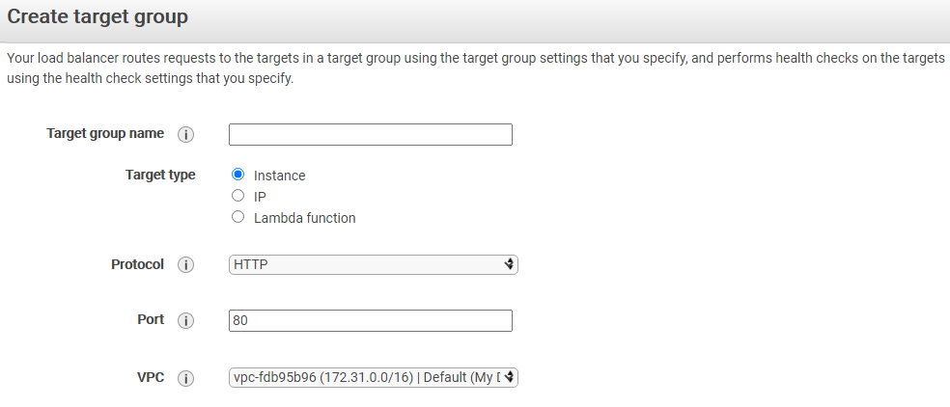

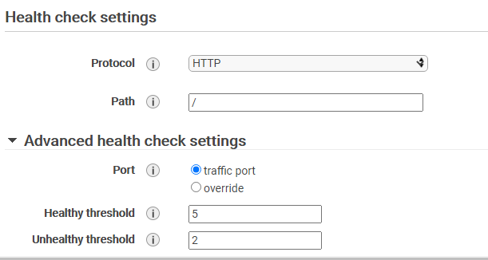

Go to Target groups and register targets

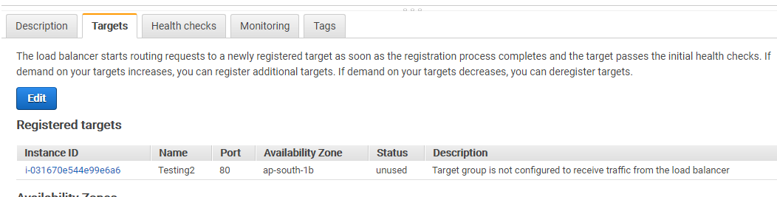

Create LB and select ALB

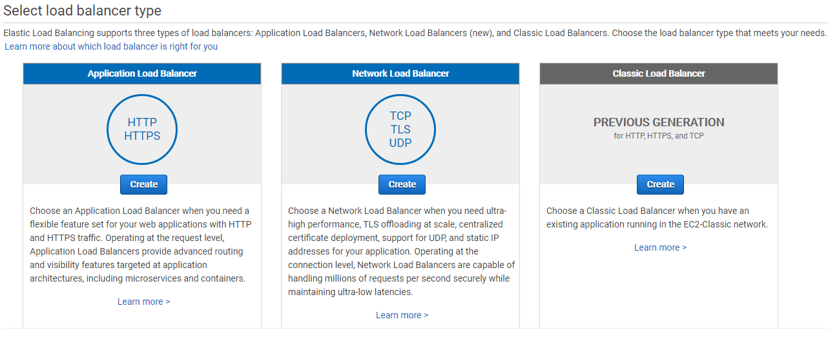
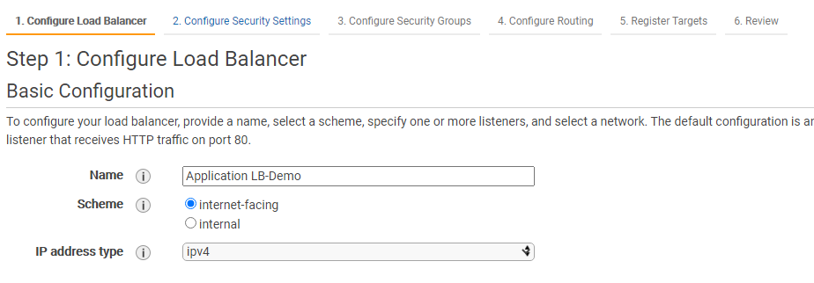

A listener is a process that checks for connection requests, using the protocol and port that you configured.

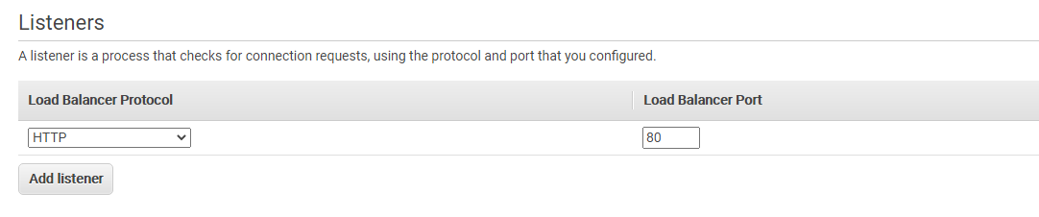

Specify the Availability Zones to enable for your load balancer. The load balancer routes traffic to the targets in these Availability Zones only. You can specify only one subnet per Availability Zone. You must specify subnets from at least two Availability Zones to increase the availability of your load balancer.

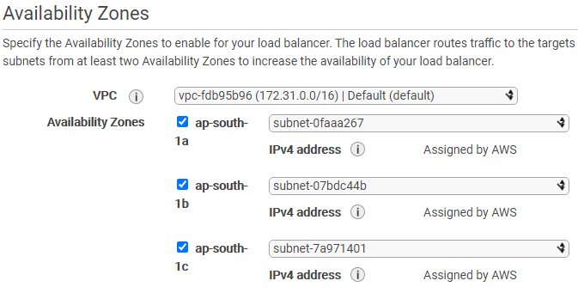

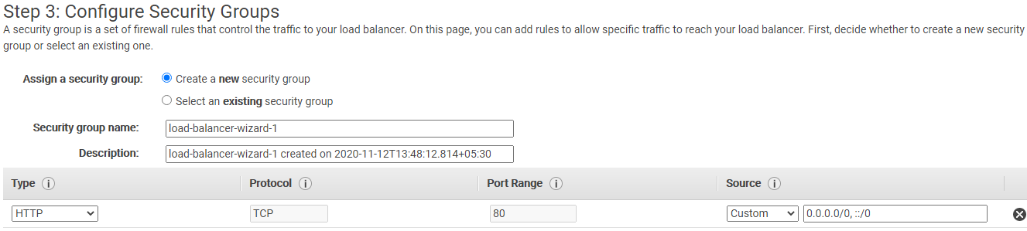

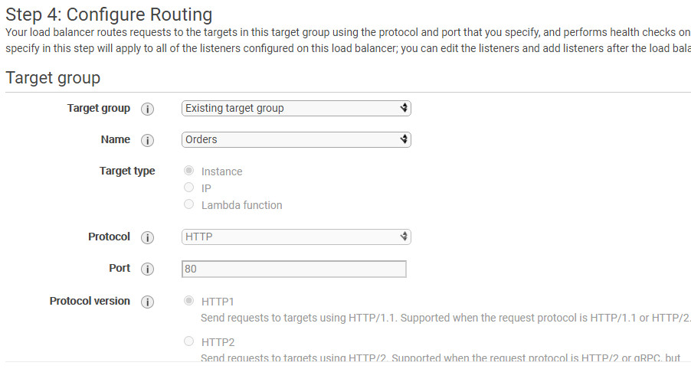

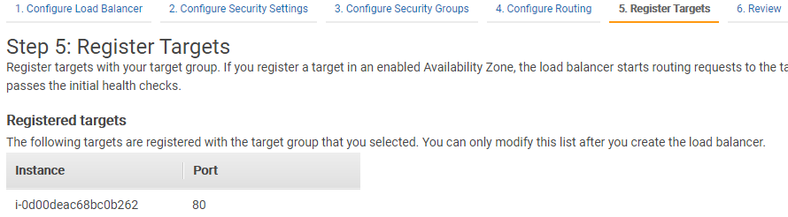

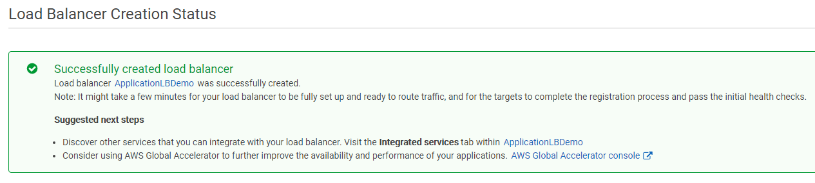

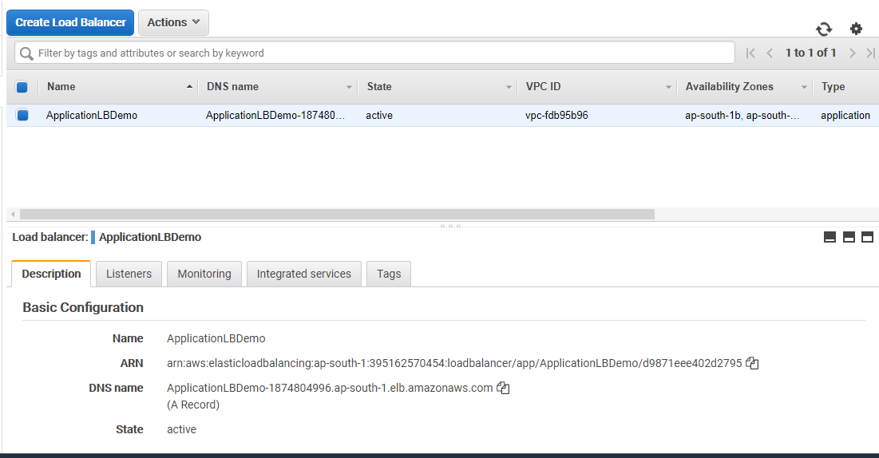

A listener checks for connection requests using its configured protocol and port, and the load balancer uses the listener rules to route requests to targets. You can add, remove, or update listeners and listener rules. You have to edit the rules.

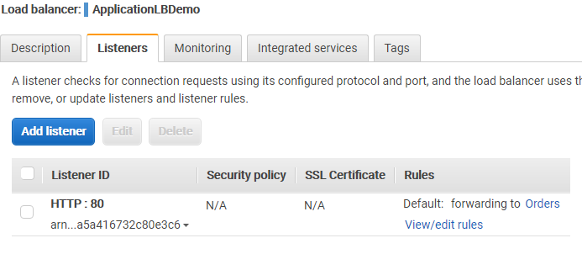
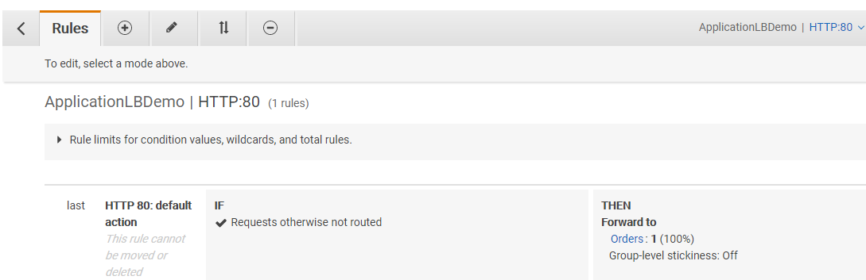

Click on + icon then click on insert rule

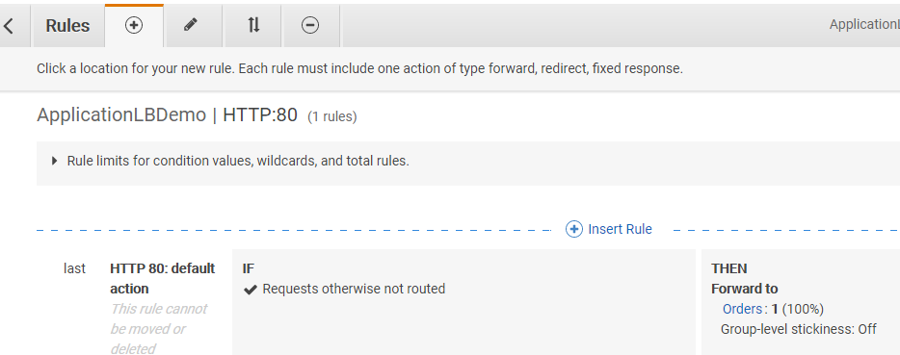

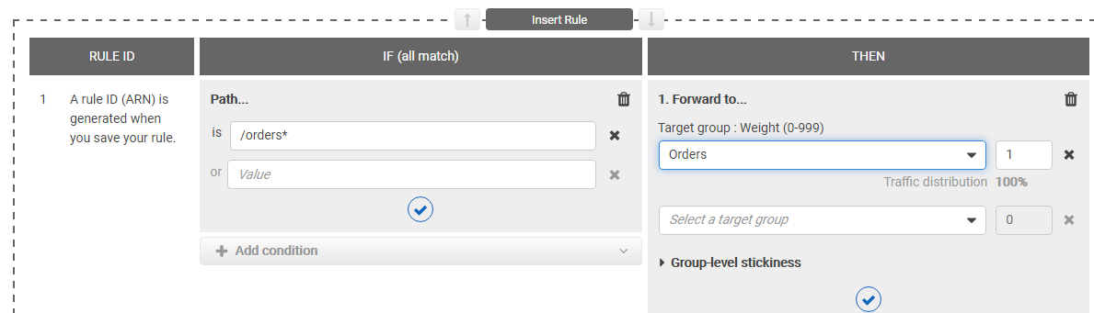

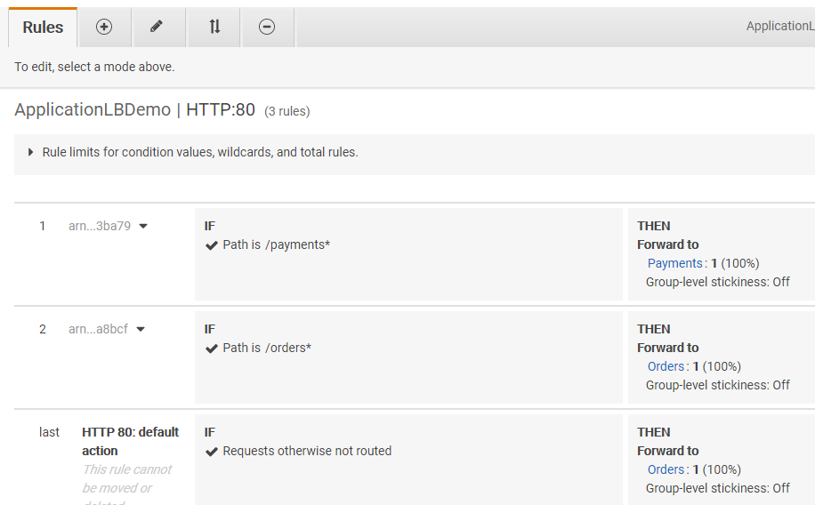

Create Classic LB in AWS

Step 1 Create 2 EC2 instances and install any web server like apache, nginx
Edit the index.html file in both instances

Step 2 click on create Classic Load balancer

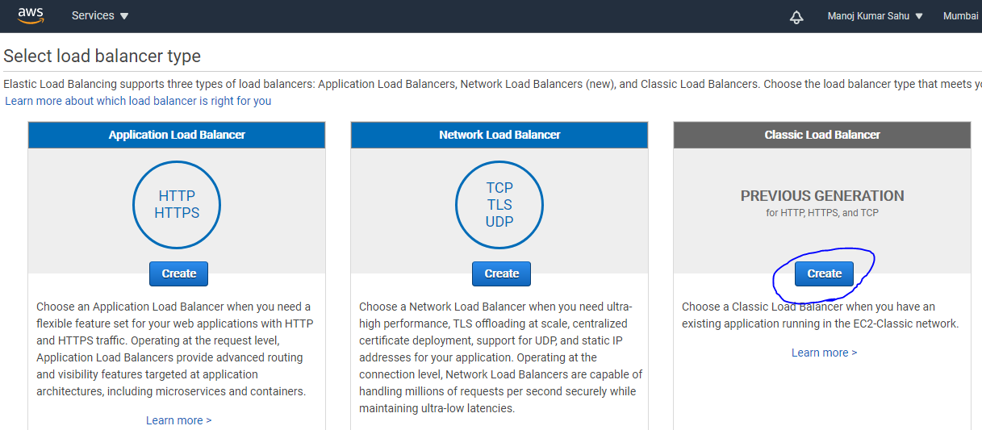

Give name to LB and make sure the LB is inside same VPC
Enable advanced VPC configuration
Leave the Listener configuration as default HTTP, if you have SSL certificate then you can go for HTTPS.

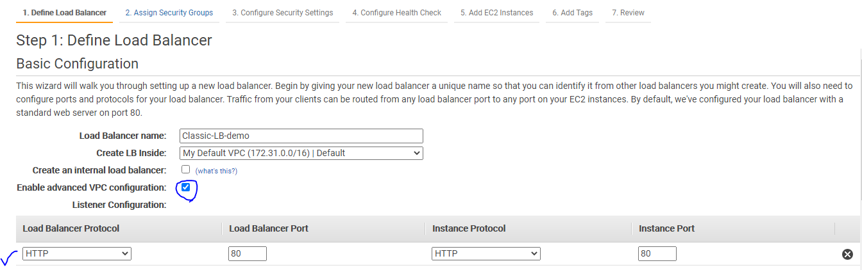

Next Select Subnets

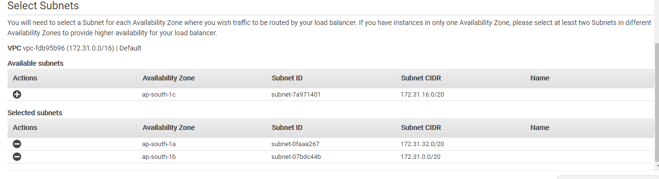

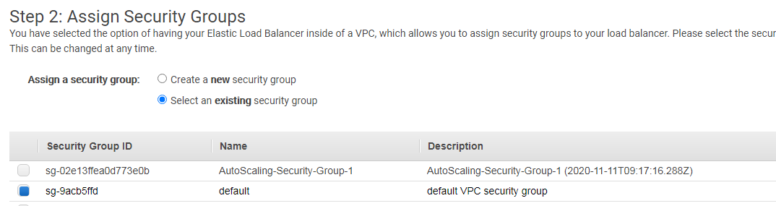

Configure Health-check

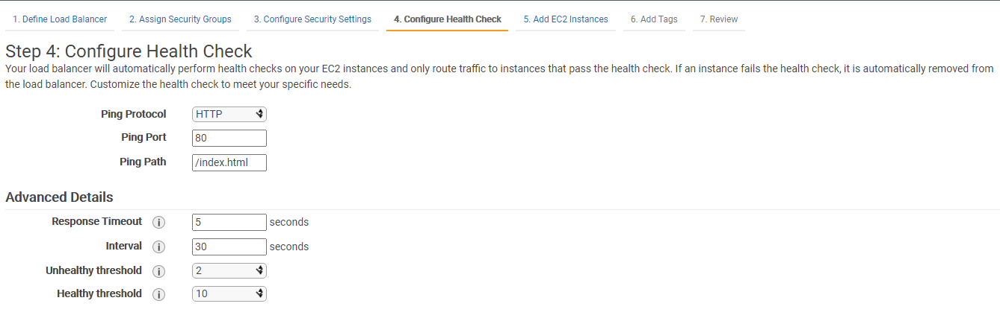

Next add EC2 instances

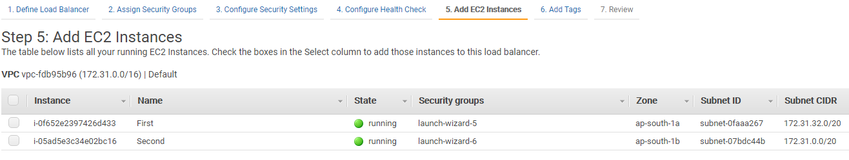

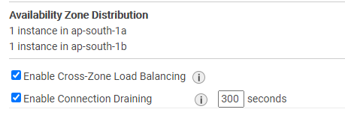
Review and Create

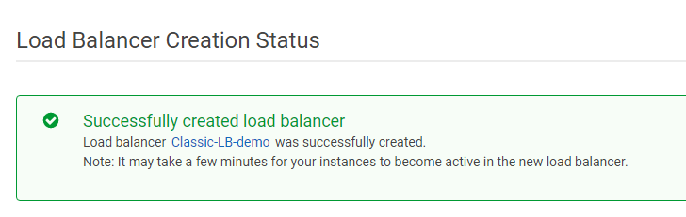
Using the DNS we will be accessing our ELB

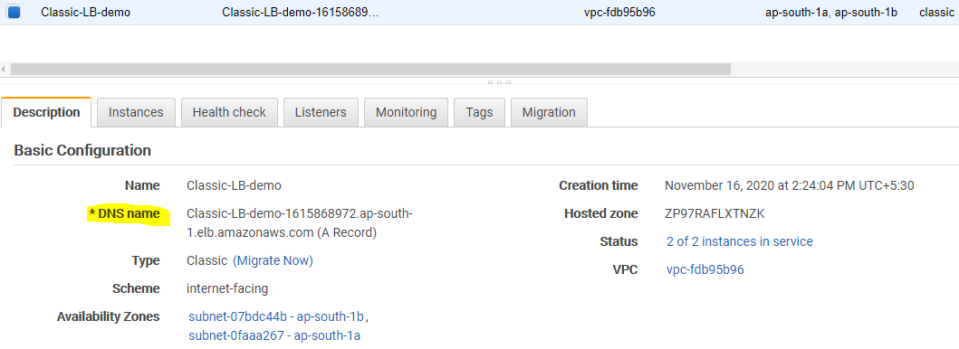
The Instance status changes from Out of Service to In Service in few secs. You can add or remove instances from here.

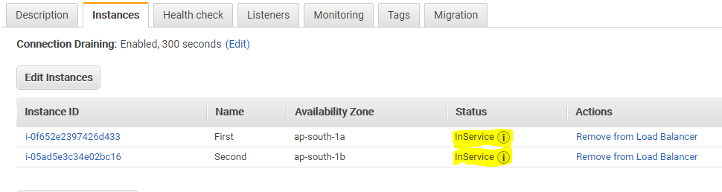

Last you can access though the DNS

